***FFNN***

**Epochs : 75**

**Chosen Model : p = s = 1**

**{'PART': 0, 'OOV': 1, 'PRON': 2, 'PROPN': 3, 'NUM': 4, 'AUX': 5, 'VERB': 6, 'CCONJ': 7, 'ADJ': 8, 'NOUN': 9, 'ADV': 10, 'INTJ': 11, 'ADP': 12, 'DET': 13}**

| **Index**  **p+s** | **Train** | **Dev** | **Test** |
| --- | --- | --- | --- |
| **0** | 0.9949439934230809 | 0.9441990364348087 | 0.9501975683890578 |
| **2** | 0.9935463981091357 | 0.9506172839506173 | 0.9571428571428572 |
| **4** | 0.9978213955400267 | 0.9445950015055706 | 0.95 |
| **5** | 0.997985818518138 | 0.9441433303221921 | 0.9521276595744681 |
| **6** | 0.9974308909670127 | 0.9409816320385426 | 0.9493920972644377 |
| **8** | 0.9948617819340253 | 0.9373682625715146 | 0.9451367781155016 |

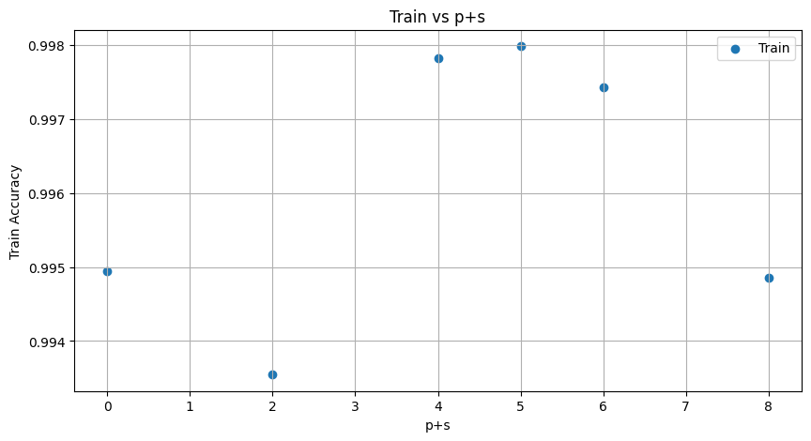

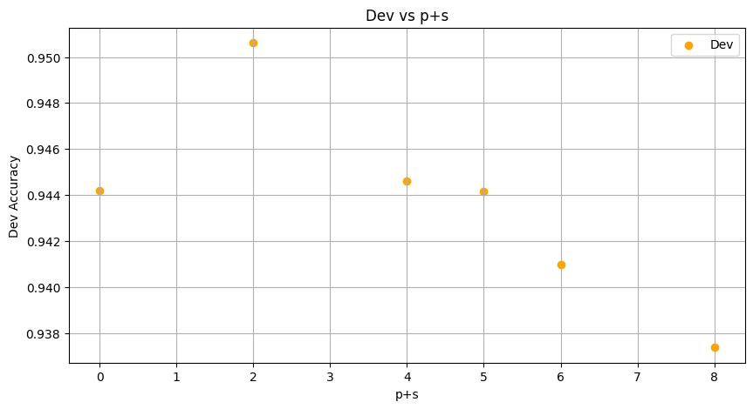

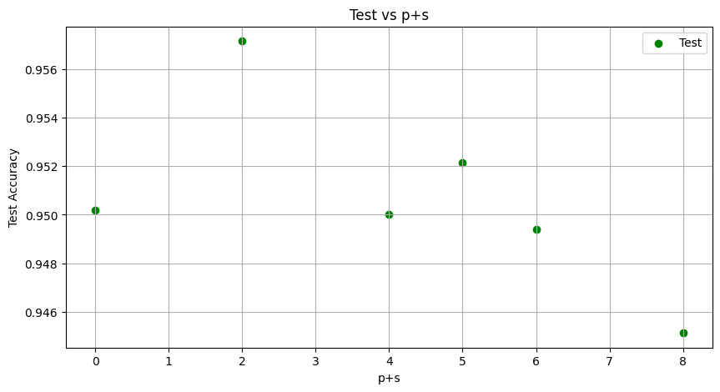

**p=0 s=0**

Training model...

Epoch 1/75, Loss: 0.8681635394124572

Epoch 2/75, Loss: 0.35202915210193625

Epoch 3/75, Loss: 0.2596902823499092

Epoch 4/75, Loss: 0.20427245551747186

Epoch 5/75, Loss: 0.16957314591487666

Epoch 6/75, Loss: 0.14631193098899725

Epoch 7/75, Loss: 0.1312463967565266

Epoch 8/75, Loss: 0.1203126020260821

Epoch 9/75, Loss: 0.11090921784008262

Epoch 10/75, Loss: 0.10405567658258327

Epoch 11/75, Loss: 0.0965028539062545

Epoch 12/75, Loss: 0.0925034311991344

Epoch 13/75, Loss: 0.08686759843637569

Epoch 14/75, Loss: 0.08153747835024609

Epoch 15/75, Loss: 0.07758819546454748

Epoch 16/75, Loss: 0.07490421935380089

Epoch 17/75, Loss: 0.07130005654339518

Epoch 18/75, Loss: 0.06734352853627916

Epoch 19/75, Loss: 0.06508594227702295

Epoch 20/75, Loss: 0.06297782451222937

Epoch 21/75, Loss: 0.06152307610673245

Epoch 22/75, Loss: 0.056311103722366695

Epoch 23/75, Loss: 0.05814633374795016

Epoch 24/75, Loss: 0.05369755152768187

Epoch 25/75, Loss: 0.05355855770064891

Epoch 26/75, Loss: 0.053604977917400376

Epoch 27/75, Loss: 0.05056259590245443

Epoch 28/75, Loss: 0.051898523207232095

Epoch 29/75, Loss: 0.04586906031170336

Epoch 30/75, Loss: 0.05332299097200227

Epoch 31/75, Loss: 0.042941992431107086

Epoch 32/75, Loss: 0.04688231437844461

Epoch 33/75, Loss: 0.042564824483232296

Epoch 34/75, Loss: 0.042139033942730504

Epoch 35/75, Loss: 0.04402194240849628

Epoch 36/75, Loss: 0.04105270667875729

Epoch 37/75, Loss: 0.04607790806931001

Epoch 38/75, Loss: 0.037554445278483915

Epoch 39/75, Loss: 0.03642117567689612

Epoch 40/75, Loss: 0.040192398745865915

Epoch 41/75, Loss: 0.035657210432148555

Epoch 42/75, Loss: 0.03820701422792562

Epoch 43/75, Loss: 0.041372663328310494

Epoch 44/75, Loss: 0.0318424846931743

Epoch 45/75, Loss: 0.03427693372870227

Epoch 46/75, Loss: 0.040103445995351

Epoch 47/75, Loss: 0.03020267218690993

Epoch 48/75, Loss: 0.032885601295572525

Epoch 49/75, Loss: 0.029611401603815268

Epoch 50/75, Loss: 0.03190327035162067

Epoch 51/75, Loss: 0.028068236914333012

Epoch 52/75, Loss: 0.03712659505356169

Epoch 53/75, Loss: 0.026550498065685817

Epoch 54/75, Loss: 0.03380538917438229

Epoch 55/75, Loss: 0.025435179396556203

Epoch 56/75, Loss: 0.042681078396663866

Epoch 57/75, Loss: 0.029647464004336852

Epoch 58/75, Loss: 0.030857799802173534

Epoch 59/75, Loss: 0.024247071703986833

Epoch 60/75, Loss: 0.033147514913023646

Epoch 61/75, Loss: 0.02347862614205847

Epoch 62/75, Loss: 0.023366906724897305

Epoch 63/75, Loss: 0.026049193323242445

Epoch 64/75, Loss: 0.023133217696116905

Epoch 65/75, Loss: 0.03149266785512778

Epoch 66/75, Loss: 0.027065620794480966

Epoch 67/75, Loss: 0.023667975118439648

Epoch 68/75, Loss: 0.022158168461175135

Epoch 69/75, Loss: 0.025709881600115978

Epoch 70/75, Loss: 0.02000249942470628

Epoch 71/75, Loss: 0.02035523636468881

Epoch 72/75, Loss: 0.02955523210419542

Epoch 73/75, Loss: 0.019444085144663947

Epoch 74/75, Loss: 0.019488982673491546

Epoch 75/75, Loss: 0.028258233310696733

Saving model...

Loading model...

**Metrics of train set:**

**sk_accuracy_train=0.9949439934230809**

classification_rep_train =

precision recall f1-score support

ADJ 1.00 0.98 0.99 1577

ADP 1.00 1.00 1.00 11098

ADV 0.93 0.95 0.94 371

AUX 1.00 0.99 1.00 1573

CCONJ 1.00 1.00 1.00 742

DET 1.00 1.00 1.00 4511

INTJ 1.00 0.99 0.99 335

NOUN 0.99 0.99 0.99 8786

NUM 0.89 0.96 0.93 785

PRON 1.00 1.00 1.00 2435

PROPN 1.00 1.00 1.00 11403

VERB 1.00 0.99 0.99 5039

**accuracy 0.99 48655**

**macro avg 0.98 0.99 0.99 48655**

**weighted avg 1.00 0.99 0.99 48655**

**recall_micro_train=0.9949439934230809**

**recall_macro_train=0.9876571029441347**

**f1_micro_train=0.9949439934230809**

**f1_macro_train=0.985654847374831**

confusion_mat_train =

[[ 1549 0 1 0 0 0 0 5 8 0 10 4]

[ 0 11091 2 0 0 0 0 0 2 0 1 2]

[ 0 0 351 0 0 0 0 2 11 0 2 5]

[ 0 0 5 1565 0 0 0 2 1 0 0 0]

[ 0 0 0 0 742 0 0 0 0 0 0 0]

[ 0 0 0 0 0 4510 0 1 0 0 0 0]

[ 0 0 0 0 0 0 331 0 1 0 0 3]

[ 1 0 3 0 0 0 0 8741 23 0 12 6]

[ 0 0 2 0 0 0 0 14 757 0 8 4]

[ 0 0 0 0 0 0 0 5 0 2428 2 0]

[ 1 1 4 0 0 0 0 9 25 0 11362 1]

[ 0 0 9 0 0 0 0 21 20 0 7 4982]]

**Metrics of dev set:**

**sk_accuracy_dev=0.9441990364348087**

classification_rep_dev =

precision recall f1-score support

ADJ 1.00 0.94 0.97 223

ADP 0.97 1.00 0.99 1456

ADV 0.85 0.92 0.89 51

AUX 0.98 0.77 0.86 296

CCONJ 1.00 0.99 1.00 107

DET 1.00 0.94 0.97 697

INTJ 1.00 1.00 1.00 35

NOUN 0.93 0.96 0.94 1130

NUM 0.89 0.82 0.86 131

PRON 0.95 1.00 0.98 314

PROPN 0.98 0.96 0.97 1565

VERB 0.89 0.99 0.94 637

**accuracy 0.96 6642**

**macro avg 0.95 0.94 0.95 6642**

**weighted avg 0.96 0.96 0.96 6642**

**recall_micro_dev=0.9591990364348087**

**recall_macro_dev=0.9405929340283952**

**f1_micro_dev=0.9591990364348087**

**f1_macro_dev=0.9458223402421592**

confusion_mat_dev =

[[ 209 0 6 0 0 0 0 4 1 0 3 0]

[ 0 1455 0 0 0 0 0 1 0 0 0 0]

[ 0 0 47 0 0 0 0 1 1 0 1 1]

[ 0 0 0 228 0 0 0 17 0 0 0 51]

[ 0 0 0 0 106 1 0 0 0 0 0 0]

[ 0 42 0 0 0 654 0 1 0 0 0 0]

[ 0 0 0 0 0 0 35 0 0 0 0 0]

[ 1 0 0 4 0 0 0 1086 3 0 17 19]

[ 0 0 1 0 0 0 0 0 108 15 5 2]

[ 0 0 0 0 0 0 0 0 0 313 1 0]

[ 0 0 1 0 0 0 0 57 6 0 1500 1]

[ 0 0 0 0 0 0 0 2 2 0 3 630]]

**Metrics of test set:**

**sk_accuracy_test=0.9501975683890578**

**classification_rep_test =**

precision recall f1-score support

ADJ 0.90 0.94 0.92 218

ADP 1.00 1.00 1.00 1491

ADV 0.86 0.64 0.74 76

AUX 0.97 0.91 0.94 239

CCONJ 1.00 0.98 0.99 109

DET 1.00 1.00 1.00 618

INTJ 1.00 1.00 1.00 36

NOUN 0.96 0.93 0.94 1240

NUM 0.83 0.80 0.81 128

PRON 0.95 1.00 0.97 286

PROPN 0.98 0.99 0.98 1516

VERB 0.89 0.96 0.93 623

**accuracy 0.97 6580**

**macro avg 0.95 0.93 0.94 6580**

**weighted avg 0.97 0.97 0.96 6580**

**recall_micro_test=0.9651975683890578**

**recall_macro_test=0.9286033754720951**

**f1_micro_test=0.9651975683890578**

**f1_macro_test=0.9352826361549704**

confusion_mat_test =

[[ 204 0 3 0 0 0 0 4 2 0 3 2]

[ 1 1489 0 0 0 0 0 0 0 0 0 1]

[ 20 0 49 0 0 0 0 1 1 0 4 1]

[ 0 0 0 218 0 0 0 21 0 0 0 0]

[ 0 0 0 0 107 2 0 0 0 0 0 0]

[ 0 0 0 0 0 616 0 2 0 0 0 0]

[ 0 0 0 0 0 0 36 0 0 0 0 0]

[ 0 0 0 6 0 0 0 1148 4 0 20 62]

[ 0 0 0 0 0 0 0 1 102 15 6 4]

[ 0 0 0 0 0 0 0 0 0 286 0 0]

[ 1 2 2 0 0 0 0 4 11 0 1495 1]

[ 0 0 3 0 0 0 0 16 3 0 0 601]]

**p=1 s=1**

Training model...

Epoch 1/75, Loss: 0.6653759327476034

Epoch 2/75, Loss: 0.24612780980540638

Epoch 3/75, Loss: 0.17956529387349995

Epoch 4/75, Loss: 0.14623236873905504

Epoch 5/75, Loss: 0.12734507840755793

Epoch 6/75, Loss: 0.11387971372364404

Epoch 7/75, Loss: 0.10279513666383021

Epoch 8/75, Loss: 0.09631142775563624

Epoch 9/75, Loss: 0.09051683592474218

Epoch 10/75, Loss: 0.08663826996357145

Epoch 11/75, Loss: 0.08059836413600248

Epoch 12/75, Loss: 0.07890300723828014

Epoch 13/75, Loss: 0.07569907029430442

Epoch 14/75, Loss: 0.07206495610263404

Epoch 15/75, Loss: 0.06965854867810013

Epoch 16/75, Loss: 0.06654168398959887

Epoch 17/75, Loss: 0.06776103299773441

Epoch 18/75, Loss: 0.06090503466500975

Epoch 19/75, Loss: 0.05945304968503259

Epoch 20/75, Loss: 0.06136599870236543

Epoch 21/75, Loss: 0.05752311471118298

Epoch 22/75, Loss: 0.05470718825074573

Epoch 23/75, Loss: 0.054227284087902596

Epoch 24/75, Loss: 0.052194644925538686

Epoch 25/75, Loss: 0.05035528555101992

Epoch 26/75, Loss: 0.04776201048969097

Epoch 27/75, Loss: 0.04898391138055789

Epoch 28/75, Loss: 0.044625931757730726

Epoch 29/75, Loss: 0.04492582787284277

Epoch 30/75, Loss: 0.050213452582072396

Epoch 31/75, Loss: 0.03999883194933826

Epoch 32/75, Loss: 0.04095282671103168

Epoch 33/75, Loss: 0.04284383164939349

Epoch 34/75, Loss: 0.040742786326788495

Epoch 35/75, Loss: 0.039360890332946416

Epoch 36/75, Loss: 0.03997906423840919

Epoch 37/75, Loss: 0.03551999892621987

Epoch 38/75, Loss: 0.03639441412826951

Epoch 39/75, Loss: 0.03632051697353788

Epoch 40/75, Loss: 0.03595019084450405

Epoch 41/75, Loss: 0.03698284534946648

Epoch 42/75, Loss: 0.03526530713839465

Epoch 43/75, Loss: 0.030376939602445554

Epoch 44/75, Loss: 0.030526801138143565

Epoch 45/75, Loss: 0.03196187283669271

Epoch 46/75, Loss: 0.029979200099296607

Epoch 47/75, Loss: 0.03327043062509442

Epoch 48/75, Loss: 0.02913917906094072

Epoch 49/75, Loss: 0.0320390529950514

Epoch 50/75, Loss: 0.027266101460495067

Epoch 51/75, Loss: 0.031791719381291314

Epoch 52/75, Loss: 0.02767385300836391

Epoch 53/75, Loss: 0.02640724379135732

Epoch 54/75, Loss: 0.026867136746667443

Epoch 55/75, Loss: 0.02534136137651716

Epoch 56/75, Loss: 0.02687800109666896

Epoch 57/75, Loss: 0.027402799325904812

Epoch 58/75, Loss: 0.026984180226998864

Epoch 59/75, Loss: 0.025604903653692855

Epoch 60/75, Loss: 0.026800537322496185

Epoch 61/75, Loss: 0.027375409019695457

Epoch 62/75, Loss: 0.020173560801264742

Epoch 63/75, Loss: 0.024542906810541356

Epoch 64/75, Loss: 0.02414080894774021

Epoch 65/75, Loss: 0.024334698399322112

Epoch 66/75, Loss: 0.026745803086403605

Epoch 67/75, Loss: 0.018100517205771667

Epoch 68/75, Loss: 0.019744566950996467

Epoch 69/75, Loss: 0.026176343799496044

Epoch 70/75, Loss: 0.02663622331811998

Epoch 71/75, Loss: 0.017239858343085206

Epoch 72/75, Loss: 0.025306915151201013

Epoch 73/75, Loss: 0.01596333922314148

Epoch 74/75, Loss: 0.02176945554171438

Epoch 75/75, Loss: 0.029869008724830497

Saving model...

Loading model...

**Metrics of train set:**

**sk_accuracy_train=0.9935463981091357**

classification_rep_train =

precision recall f1-score support

ADJ 0.97 0.98 0.98 1577

ADP 1.00 1.00 1.00 11098

ADV 0.95 0.93 0.94 371

AUX 1.00 1.00 1.00 1573

CCONJ 1.00 1.00 1.00 742

DET 1.00 1.00 1.00 4511

INTJ 1.00 0.98 0.99 335

NOUN 0.98 0.99 0.99 8786

NUM 0.95 0.98 0.96 785

PRON 1.00 1.00 1.00 2435

PROPN 1.00 1.00 1.00 11403

VERB 1.00 0.98 0.99 5039

**accuracy 0.99 48655**

**macro avg 0.99 0.99 0.99 48655**

**weighted avg 0.99 0.99 0.99 48655**

**recall_micro_train=0.9935463981091357**

**recall_macro_train=0.9854504974831704**

**f1_micro_train=0.9935463981091357**

**f1_macro_train=0.9863229343901038**

confusion_mat_train =

[[ 1544 2 0 0 0 0 0 15 6 0 10 0]

[ 3 11090 2 0 0 0 0 1 1 0 1 0]

[ 1 1 345 0 0 0 0 8 6 1 8 1]

[ 3 0 0 1567 0 0 0 1 2 0 0 0]

[ 0 0 0 0 742 0 0 0 0 0 0 0]

[ 7 2 1 0 0 4490 0 8 0 0 2 1]

[ 0 0 3 0 0 0 328 0 0 0 0 4]

[ 17 1 0 0 0 0 0 8736 13 0 18 1]

[ 2 0 1 0 0 0 0 10 767 0 4 1]

[ 1 0 0 0 0 0 0 1 0 2433 0 0]

[ 4 0 0 0 0 0 0 32 3 0 11364 0]

[ 6 9 12 0 0 0 0 59 9 0 9 4935]]

**Metrics of dev set:**

**sk_accuracy_dev=0.9506172839506173**

classification_rep_dev =

precision recall f1-score support

ADJ 0.94 0.93 0.93 223

ADP 0.97 1.00 0.98 1456

ADV 0.77 0.80 0.79 51

AUX 0.97 0.76 0.85 296

CCONJ 1.00 0.99 1.00 107

DET 1.00 0.93 0.96 697

INTJ 1.00 0.97 0.99 35

NOUN 0.91 0.95 0.93 1130

NUM 0.90 0.85 0.87 131

PRON 0.95 0.99 0.97 314

PROPN 0.98 0.95 0.97 1565

VERB 0.89 0.96 0.92 637

**accuracy 0.95 6642**

**macro avg 0.94 0.92 0.93 6642**

**weighted avg 0.95 0.95 0.95 6642**

**recall_micro_dev=0.9506172839506173**

**recall_macro_dev=0.9238191977339062**

**f1_micro_dev=0.9506172839506173**

**f1_macro_dev=0.9298615697541335**

confusion_mat_dev =

[[ 207 1 7 0 0 0 0 5 1 0 1 1]

[ 1 1449 1 1 0 0 0 3 0 0 1 0]

[ 2 0 41 1 0 0 0 5 0 0 1 1]

[ 1 1 0 224 0 0 0 17 0 0 2 51]

[ 0 1 0 0 106 0 0 0 0 0 0 0]

[ 2 44 0 0 0 648 0 1 1 0 0 1]

[ 0 0 0 0 0 0 34 0 0 0 0 1]

[ 4 0 3 4 0 0 0 1074 3 0 22 20]

[ 1 0 0 0 0 0 0 2 111 15 2 0]

[ 0 0 0 0 0 0 0 1 0 312 1 0]

[ 2 1 0 0 0 0 0 61 5 0 1494 2]

[ 1 3 1 2 0 0 0 10 3 1 2 614]]

**Metrics of test set:**

**sk_accuracy_test=0.9571428571428572**

classification_rep_test =

precision recall f1-score support

ADJ 0.85 0.94 0.89 218

ADP 0.99 1.00 0.99 1491

ADV 0.85 0.59 0.70 76

AUX 0.96 0.91 0.93 239

CCONJ 0.99 0.97 0.98 109

DET 1.00 0.98 0.99 618

INTJ 0.97 1.00 0.99 36

NOUN 0.94 0.91 0.93 1240

NUM 0.87 0.80 0.83 128

PRON 0.95 0.99 0.97 286

PROPN 0.97 0.99 0.98 1516

VERB 0.90 0.94 0.92 623

**accuracy 0.96 6580**

**macro avg 0.94 0.92 0.93 6580**

**weighted avg 0.96 0.96 0.96 6580**

**recall_micro_test=0.9571428571428572**

**recall_macro_test=0.9186666817258099**

**f1_micro_test=0.9571428571428572**

**f1_macro_test=0.9250386356217705**

confusion_mat_test =

[[ 204 1 4 0 0 0 0 5 4 0 0 0]

[ 1 1484 0 1 0 1 0 1 0 0 1 2]

[ 21 0 45 1 0 0 0 4 1 0 4 0]

[ 0 0 0 218 0 0 0 21 0 0 0 0]

[ 0 0 0 0 106 0 0 1 0 0 2 0]

[ 2 0 0 1 0 607 0 5 0 0 3 0]

[ 0 0 0 0 0 0 36 0 0 0 0 0]

[ 4 1 0 7 1 0 0 1131 2 0 29 65]

[ 1 0 2 0 0 0 0 2 103 16 4 0]

[ 0 0 0 0 0 0 0 2 0 284 0 0]

[ 1 4 1 0 0 0 0 8 6 0 1496 0]

[ 5 2 1 0 0 2 1 18 3 0 7 584]]

**p=2 s=2**

Training model...

Epoch 1/75, Loss: 0.6669412596976083

Epoch 2/75, Loss: 0.23950119581166532

Epoch 3/75, Loss: 0.17561681083135514

Epoch 4/75, Loss: 0.14639532106283576

Epoch 5/75, Loss: 0.1245593965951838

Epoch 6/75, Loss: 0.11139748842790771

Epoch 7/75, Loss: 0.0986522575886247

Epoch 8/75, Loss: 0.09120297909271567

Epoch 9/75, Loss: 0.08413295384341025

Epoch 10/75, Loss: 0.07834551974065705

Epoch 11/75, Loss: 0.07611020553505854

Epoch 12/75, Loss: 0.06790540271356663

Epoch 13/75, Loss: 0.06560826117815187

Epoch 14/75, Loss: 0.06278679532990375

Epoch 15/75, Loss: 0.05956481083791942

Epoch 16/75, Loss: 0.055731257978532046

Epoch 17/75, Loss: 0.05453096036832907

Epoch 18/75, Loss: 0.0532482283777859

Epoch 19/75, Loss: 0.04892798243376577

Epoch 20/75, Loss: 0.047698379530514874

Epoch 21/75, Loss: 0.04262518438098062

Epoch 22/75, Loss: 0.04187127529498071

Epoch 23/75, Loss: 0.043483608516886624

Epoch 24/75, Loss: 0.03786127808232445

Epoch 25/75, Loss: 0.03751578032158504

Epoch 26/75, Loss: 0.039012994108956034

Epoch 27/75, Loss: 0.032980726797286995

Epoch 28/75, Loss: 0.036319219190098805

Epoch 29/75, Loss: 0.030915478442877762

Epoch 30/75, Loss: 0.030771825520483825

Epoch 31/75, Loss: 0.03091167194502119

Epoch 32/75, Loss: 0.027442443065213575

Epoch 33/75, Loss: 0.0267454694849118

Epoch 34/75, Loss: 0.03180381721686755

Epoch 35/75, Loss: 0.025704050450629526

Epoch 36/75, Loss: 0.02538777613393421

Epoch 37/75, Loss: 0.029070953044625574

Epoch 38/75, Loss: 0.022571083300139683

Epoch 39/75, Loss: 0.026267587507243402

Epoch 40/75, Loss: 0.020667055550925115

Epoch 41/75, Loss: 0.028094953834608468

Epoch 42/75, Loss: 0.021779593421269075

Epoch 43/75, Loss: 0.021487854677080743

Epoch 44/75, Loss: 0.02135819606964459

Epoch 45/75, Loss: 0.023956931393654166

Epoch 46/75, Loss: 0.02171284635889645

Epoch 47/75, Loss: 0.021565944876335286

Epoch 48/75, Loss: 0.021704151510148078

Epoch 49/75, Loss: 0.01769023550826999

Epoch 50/75, Loss: 0.015553645015377409

Epoch 51/75, Loss: 0.02123445989517687

Epoch 52/75, Loss: 0.018470431407131723

Epoch 53/75, Loss: 0.023528578550442363

Epoch 54/75, Loss: 0.017549729169839212

Epoch 55/75, Loss: 0.020739572657214662

Epoch 56/75, Loss: 0.019251615818965527

Epoch 57/75, Loss: 0.014290918878349962

Epoch 58/75, Loss: 0.02569019970423699

Epoch 59/75, Loss: 0.013361575072304229

Epoch 60/75, Loss: 0.017239952922943027

Epoch 61/75, Loss: 0.015290537125674512

Epoch 62/75, Loss: 0.018410970048088858

Epoch 63/75, Loss: 0.01790050916941143

Epoch 64/75, Loss: 0.010703432608934253

Epoch 65/75, Loss: 0.021755999071883646

Epoch 66/75, Loss: 0.01278015168899959

Epoch 67/75, Loss: 0.021185490611762146

Epoch 68/75, Loss: 0.010793651018968667

Epoch 69/75, Loss: 0.014587920354463782

Epoch 70/75, Loss: 0.015520555621741814

Epoch 71/75, Loss: 0.016898193668220072

Epoch 72/75, Loss: 0.012560404137468686

Epoch 73/75, Loss: 0.013122266575809612

Epoch 74/75, Loss: 0.016777434418168237

Epoch 75/75, Loss: 0.013163483590862165

Saving model...

Loading model...

**Metrics of train set:**

**sk_accuracy_train=0.9978213955400267**

classification_rep_train =

precision recall f1-score support

ADJ 0.99 0.99 0.99 1577

ADP 1.00 1.00 1.00 11098

ADV 0.98 0.98 0.98 371

AUX 1.00 1.00 1.00 1573

CCONJ 1.00 1.00 1.00 742

DET 1.00 1.00 1.00 4511

INTJ 1.00 0.98 0.99 335

NOUN 1.00 0.99 1.00 8786

NUM 0.98 1.00 0.99 785

PRON 1.00 1.00 1.00 2435

PROPN 1.00 1.00 1.00 11403

VERB 1.00 1.00 1.00 5039

**accuracy 1.00 48655**

**macro avg 1.00 1.00 1.00 48655**

**weighted avg 1.00 1.00 1.00 48655**

**recall_micro_train=0.9978213955400267**

**recall_macro_train=0.9952450385389895**

**f1_micro_train=0.9978213955400267**

**f1_macro_train=0.9952303008786357**

confusion_mat_train =

[[ 1561 0 0 0 0 1 0 3 2 0 3 7]

[ 0 11091 0 0 0 0 0 2 0 0 4 1]

[ 1 0 365 0 0 0 0 0 1 0 4 0]

[ 0 0 0 1573 0 0 0 0 0 0 0 0]

[ 0 0 0 0 742 0 0 0 0 0 0 0]

[ 0 0 0 0 0 4510 0 0 0 0 1 0]

[ 0 0 6 0 0 0 329 0 0 0 0 0]

[ 11 0 0 2 0 1 0 8737 10 0 23 2]

[ 0 0 0 0 0 0 0 1 783 0 0 1]

[ 2 0 0 0 0 0 0 1 0 2432 0 0]

[ 0 0 0 0 0 0 0 3 2 0 11398 0]

[ 1 0 0 0 0 1 0 1 3 0 5 5028]]

**Metrics of dev set:**

**sk_accuracy_dev=0.9445950015055706**

classification_rep_dev =

precision recall f1-score support

ADJ 0.94 0.88 0.91 223

ADP 0.97 0.99 0.98 1456

ADV 0.76 0.73 0.74 51

AUX 0.96 0.75 0.84 296

CCONJ 1.00 0.99 1.00 107

DET 0.99 0.93 0.96 697

INTJ 1.00 0.91 0.96 35

NOUN 0.91 0.94 0.92 1130

NUM 0.87 0.83 0.85 131

PRON 0.95 0.99 0.97 314

PROPN 0.97 0.95 0.96 1565

VERB 0.87 0.97 0.92 637

**accuracy 0.94 6642**

**macro avg 0.93 0.91 0.92 6642**

**weighted avg 0.95 0.94 0.94 6642**

**recall_micro_dev=0.9445950015055706**

**recall_macro_dev=0.9055198059501973**

**f1_micro_dev=0.9445950015055706**

**f1_macro_dev=0.917055619794931**

confusion_mat_dev =

[[ 196 1 3 0 0 1 0 12 5 0 2 3]

[ 0 1439 1 1 0 2 0 3 0 0 4 6]

[ 0 1 37 1 0 1 0 5 0 0 4 2]

[ 0 0 1 222 0 0 0 17 0 0 2 54]

[ 0 0 0 0 106 0 0 0 0 0 0 1]

[ 1 42 0 1 0 649 0 1 0 0 2 1]

[ 0 0 2 0 0 0 32 0 0 0 0 1]

[ 8 1 1 4 0 1 0 1063 4 0 26 22]

[ 0 0 0 0 0 0 0 3 109 15 4 0]

[ 0 0 0 1 0 0 0 0 0 312 1 0]

[ 1 1 1 0 0 1 0 62 4 0 1493 2]

[ 2 1 3 2 0 1 0 4 3 0 5 616]]

**Metrics of test set:**

**sk_accuracy_test=0.95**

classification_rep_test =

precision recall f1-score support

ADJ 0.84 0.88 0.86 218

ADP 1.00 0.99 0.99 1491

ADV 0.80 0.53 0.63 76

AUX 0.95 0.90 0.93 239

CCONJ 0.99 0.96 0.98 109

DET 0.99 0.99 0.99 618

INTJ 0.97 0.97 0.97 36

NOUN 0.94 0.90 0.92 1240

NUM 0.79 0.77 0.78 128

PRON 0.94 1.00 0.97 286

PROPN 0.96 0.98 0.97 1516

VERB 0.87 0.94 0.90 623

**accuracy 0.95 6580**

**macro avg 0.92 0.90 0.91 6580**

**weighted avg 0.95 0.95 0.95 6580**

**recall_micro_test=0.95**

**recall_macro_test=0.9011578223882216**

**f1_micro_test=0.9500000000000001**

**f1_macro_test=0.9083186329604063**

confusion_mat_test =

[[ 192 0 2 0 0 0 0 11 4 0 5 4]

[ 2 1476 2 2 1 2 0 2 1 0 2 1]

[ 19 0 40 2 0 0 1 3 0 0 5 6]

[ 0 0 0 216 0 0 0 21 0 0 2 0]

[ 1 0 0 0 105 1 0 0 0 0 2 0]

[ 1 0 1 0 0 609 0 3 0 0 3 1]

[ 0 0 0 0 0 0 35 0 0 0 0 1]

[ 5 0 1 7 0 0 0 1118 8 0 34 67]

[ 3 0 2 0 0 0 0 4 99 15 3 2]

[ 0 0 0 0 0 1 0 0 0 285 0 0]

[ 2 0 1 0 0 1 0 6 9 1 1493 3]

[ 3 3 1 1 0 2 0 17 4 1 8 583]]

**p=2 s=3**

Training model...

Epoch 1/75, Loss: 0.6066811263619992

Epoch 2/75, Loss: 0.22933205328734882

Epoch 3/75, Loss: 0.17128477451170007

Epoch 4/75, Loss: 0.13629795124316185

Epoch 5/75, Loss: 0.11856527653315965

Epoch 6/75, Loss: 0.10581943224173201

Epoch 7/75, Loss: 0.09537249560231148

Epoch 8/75, Loss: 0.08646029437575171

Epoch 9/75, Loss: 0.08122710557272059

Epoch 10/75, Loss: 0.07334742390944742

Epoch 11/75, Loss: 0.0698228381132357

Epoch 12/75, Loss: 0.06510573317836504

Epoch 13/75, Loss: 0.06014025303823983

Epoch 14/75, Loss: 0.058310281188391225

Epoch 15/75, Loss: 0.05704072710093289

Epoch 16/75, Loss: 0.053776597283286764

Epoch 17/75, Loss: 0.04991354832319242

Epoch 18/75, Loss: 0.04713122321289517

Epoch 19/75, Loss: 0.04218561193977689

Epoch 20/75, Loss: 0.04510606291058356

Epoch 21/75, Loss: 0.038483053487894214

Epoch 22/75, Loss: 0.0379830002536333

Epoch 23/75, Loss: 0.04013793948985319

Epoch 24/75, Loss: 0.03216634290323837

Epoch 25/75, Loss: 0.03753336011208

Epoch 26/75, Loss: 0.03412311541538566

Epoch 27/75, Loss: 0.02824934760778069

Epoch 28/75, Loss: 0.03275061313618508

Epoch 29/75, Loss: 0.033253448247863575

Epoch 30/75, Loss: 0.02543197648778956

Epoch 31/75, Loss: 0.025191040590637072

Epoch 32/75, Loss: 0.03222002559424767

Epoch 33/75, Loss: 0.030199145966179865

Epoch 34/75, Loss: 0.02118405998950569

Epoch 35/75, Loss: 0.022600579856360242

Epoch 36/75, Loss: 0.02308721250918954

Epoch 37/75, Loss: 0.020994994436135006

Epoch 38/75, Loss: 0.026191695994982212

Epoch 39/75, Loss: 0.02287128277579596

Epoch 40/75, Loss: 0.02048208353646305

Epoch 41/75, Loss: 0.02066043517036689

Epoch 42/75, Loss: 0.01853551409434247

Epoch 43/75, Loss: 0.024111261559951896

Epoch 44/75, Loss: 0.019578372295762408

Epoch 45/75, Loss: 0.017679350775969934

Epoch 46/75, Loss: 0.0215711614083332

Epoch 47/75, Loss: 0.01713939163038143

Epoch 48/75, Loss: 0.017011324452206728

Epoch 49/75, Loss: 0.018371516570437785

Epoch 50/75, Loss: 0.01911885707345314

Epoch 51/75, Loss: 0.01736232925555088

Epoch 52/75, Loss: 0.01692050680433803

Epoch 53/75, Loss: 0.018151474712912

Epoch 54/75, Loss: 0.011723280555726547

Epoch 55/75, Loss: 0.01913941790003311

Epoch 56/75, Loss: 0.019848266462664643

Epoch 57/75, Loss: 0.012695891056716143

Epoch 58/75, Loss: 0.008338540084068818

Epoch 59/75, Loss: 0.019329817401498584

Epoch 60/75, Loss: 0.022936138921599583

Epoch 61/75, Loss: 0.01015816558886662

Epoch 62/75, Loss: 0.0131897474774696

Epoch 63/75, Loss: 0.02279871449152917

Epoch 64/75, Loss: 0.011174469034143786

Epoch 65/75, Loss: 0.017684894482143613

Epoch 66/75, Loss: 0.01443913824708327

Epoch 67/75, Loss: 0.014213146331462043

Epoch 68/75, Loss: 0.01043119764159893

Epoch 69/75, Loss: 0.01746341197240412

Epoch 70/75, Loss: 0.011987612876596334

Epoch 71/75, Loss: 0.01284054764689252

Epoch 72/75, Loss: 0.01015789966021862

Epoch 73/75, Loss: 0.018313447507931718

Epoch 74/75, Loss: 0.014498993806539563

Epoch 75/75, Loss: 0.007623427357451297

Saving model...

Loading model...

**Metrics of train set:**

**sk_accuracy_train=0.997985818518138**

classification_rep_train =

precision recall f1-score support

ADJ 0.99 0.99 0.99 1577

ADP 1.00 1.00 1.00 11098

ADV 1.00 0.99 0.99 371

AUX 1.00 1.00 1.00 1573

CCONJ 1.00 1.00 1.00 742

DET 1.00 1.00 1.00 4511

INTJ 1.00 1.00 1.00 335

NOUN 1.00 1.00 1.00 8786

NUM 0.97 1.00 0.98 785

PRON 1.00 1.00 1.00 2435

PROPN 1.00 1.00 1.00 11403

VERB 1.00 1.00 1.00 5039

**accuracy 1.00 48655**

**macro avg 1.00 1.00 1.00 48655**

**weighted avg 1.00 1.00 1.00 48655**

**recall_micro_train=0.997985818518138**

**recall_macro_train=0.9971744746310826**

**f1_micro_train=0.997985818518138**

**f1_macro_train=0.9967612133829397**

confusion_mat_train =

[[ 1568 0 0 0 0 0 0 5 3 0 0 1]

[ 0 11093 0 0 0 0 0 2 0 0 0 3]

[ 0 0 367 0 0 0 0 3 0 0 1 0]

[ 0 0 0 1573 0 0 0 0 0 0 0 0]

[ 0 0 0 0 742 0 0 0 0 0 0 0]

[ 0 0 0 0 0 4510 0 1 0 0 0 0]

[ 0 0 0 0 0 0 334 1 0 0 0 0]

[ 10 0 0 1 0 0 0 8746 10 0 12 7]

[ 0 0 0 0 0 0 0 2 782 0 0 1]

[ 0 0 0 0 0 0 0 1 0 2434 0 0]

[ 2 0 0 0 0 0 0 7 6 0 11387 1]

[ 0 0 0 0 0 0 0 13 3 0 2 5021]]

**Metrics of dev set:**

**sk_accuracy_dev=0.9441433303221921**

classification_rep_dev =

precision recall f1-score support

ADJ 0.93 0.84 0.88 223

ADP 0.97 0.99 0.98 1456

ADV 0.75 0.75 0.75 51

AUX 0.96 0.74 0.84 296

CCONJ 0.97 0.99 0.98 107

DET 0.99 0.93 0.96 697

INTJ 1.00 1.00 1.00 35

NOUN 0.90 0.95 0.92 1130

NUM 0.91 0.85 0.88 131

PRON 0.95 1.00 0.97 314

PROPN 0.98 0.95 0.96 1565

VERB 0.86 0.96 0.91 637

**accuracy 0.94 6642**

**macro avg 0.93 0.91 0.92 6642**

**weighted avg 0.95 0.94 0.94 6642**

**recall_micro_dev=0.9441433303221921**

**recall_macro_dev=0.9120591242485095**

**f1_micro_dev=0.9441433303221921**

**f1_macro_dev=0.9195467230921373**

confusion_mat_dev =

[[ 187 1 8 0 1 2 0 14 1 1 4 4]

[ 2 1443 1 0 1 0 0 4 0 0 0 5]

[ 1 0 38 2 0 0 0 5 0 0 3 2]

[ 1 1 0 220 0 2 0 18 0 0 1 53]

[ 0 0 0 0 106 0 0 0 0 0 0 1]

[ 2 41 0 1 0 649 0 1 0 0 0 3]

[ 0 0 0 0 0 0 35 0 0 0 0 0]

[ 6 0 0 5 0 0 0 1068 3 0 22 26]

[ 1 0 0 0 0 0 0 2 111 15 2 0]

[ 0 0 0 0 0 0 0 0 0 314 0 0]

[ 1 2 0 0 0 1 0 67 4 0 1487 3]

[ 0 0 4 0 1 0 0 10 3 1 5 613]]

**Metrics of test set:**

**sk_accuracy_test=0.9521276595744681**

classification_rep_test =

precision recall f1-score support

ADJ 0.82 0.88 0.85 218

ADP 0.99 0.99 0.99 1491

ADV 0.87 0.61 0.71 76

AUX 0.94 0.90 0.92 239

CCONJ 1.00 0.97 0.99 109

DET 0.99 0.98 0.99 618

INTJ 0.95 0.97 0.96 36

NOUN 0.94 0.91 0.92 1240

NUM 0.80 0.77 0.79 128

PRON 0.95 0.99 0.97 286

PROPN 0.97 0.98 0.98 1516

VERB 0.88 0.95 0.91 623

**accuracy 0.95 6580**

**macro avg 0.93 0.91 0.91 6580**

**weighted avg 0.95 0.95 0.95 6580**

**recall_micro_test=0.9521276595744681**

**recall_macro_test=0.9084664736197056**

**f1_micro_test=0.9521276595744681**

**f1_macro_test=0.9146494786148335**

confusion_mat_test =

[[ 191 2 2 0 0 1 0 11 5 0 3 3]

[ 4 1481 1 0 0 1 0 2 1 0 0 1]

[ 17 1 46 1 0 0 1 2 0 1 4 3]

[ 0 0 0 215 0 0 0 21 0 0 1 2]

[ 0 0 0 0 106 0 0 2 0 0 0 1]

[ 3 0 1 1 0 605 1 4 0 0 3 0]

[ 0 0 0 0 0 0 35 0 0 0 0 1]

[ 7 3 1 10 0 0 0 1128 5 0 22 64]

[ 4 0 0 1 0 0 0 4 99 15 3 2]

[ 0 0 0 0 0 2 0 0 0 284 0 0]

[ 4 1 2 0 0 1 0 13 9 0 1484 2]

[ 3 2 0 0 0 0 0 19 4 0 4 591]]

**p=3 s=3**

Training model...

Epoch 1/75, Loss: 0.6136231879543381

Epoch 2/75, Loss: 0.23109073894840032

Epoch 3/75, Loss: 0.17369523159205014

Epoch 4/75, Loss: 0.14257437405733298

Epoch 5/75, Loss: 0.12236861573867548

Epoch 6/75, Loss: 0.10924358293169353

Epoch 7/75, Loss: 0.09828827280250443

Epoch 8/75, Loss: 0.089253970347351

Epoch 9/75, Loss: 0.07971711097287905

Epoch 10/75, Loss: 0.077430327652688

Epoch 11/75, Loss: 0.06843705482887405

Epoch 12/75, Loss: 0.06674183667781206

Epoch 13/75, Loss: 0.06004759395429583

Epoch 14/75, Loss: 0.05781155366379184

Epoch 15/75, Loss: 0.05604326767724867

Epoch 16/75, Loss: 0.04937365675293357

Epoch 17/75, Loss: 0.0486428805256878

Epoch 18/75, Loss: 0.042729378669892445

Epoch 19/75, Loss: 0.042962512109836634

Epoch 20/75, Loss: 0.039832713588680686

Epoch 21/75, Loss: 0.03901295537335678

Epoch 22/75, Loss: 0.034946161869283225

Epoch 23/75, Loss: 0.0350869149795677

Epoch 24/75, Loss: 0.02928802635264728

Epoch 25/75, Loss: 0.03548459676486643

Epoch 26/75, Loss: 0.02774214527897789

Epoch 27/75, Loss: 0.02906649150464114

Epoch 28/75, Loss: 0.032239798807433245

Epoch 29/75, Loss: 0.025808440042114297

Epoch 30/75, Loss: 0.02532763664652002

Epoch 31/75, Loss: 0.02836155713044914

Epoch 32/75, Loss: 0.025846273821412875

Epoch 33/75, Loss: 0.02419761915481963

Epoch 34/75, Loss: 0.023974995278144416

Epoch 35/75, Loss: 0.020739304348079787

Epoch 36/75, Loss: 0.02409619288076659

Epoch 37/75, Loss: 0.023893752229001208

Epoch 38/75, Loss: 0.017369652433574842

Epoch 39/75, Loss: 0.021500226730614854

Epoch 40/75, Loss: 0.025041418425960933

Epoch 41/75, Loss: 0.01666209857973236

Epoch 42/75, Loss: 0.017225050536275908

Epoch 43/75, Loss: 0.017854187815707342

Epoch 44/75, Loss: 0.021187122239319043

Epoch 45/75, Loss: 0.022711282643601925

Epoch 46/75, Loss: 0.013168443667398966

Epoch 47/75, Loss: 0.026872589642840984

Epoch 48/75, Loss: 0.017059267377236842

Epoch 49/75, Loss: 0.012087913963095736

Epoch 50/75, Loss: 0.017103950323258305

Epoch 51/75, Loss: 0.017553822486073296

Epoch 52/75, Loss: 0.017402153708078984

Epoch 53/75, Loss: 0.018220528052628183

Epoch 54/75, Loss: 0.01992841178551755

Epoch 55/75, Loss: 0.01091572596809779

Epoch 56/75, Loss: 0.01529875124308467

Epoch 57/75, Loss: 0.015908462319284142

Epoch 58/75, Loss: 0.016718878429690068

Epoch 59/75, Loss: 0.014323895355564581

Epoch 60/75, Loss: 0.016232970950852632

Epoch 61/75, Loss: 0.011443299988896864

Epoch 62/75, Loss: 0.015495828033144306

Epoch 63/75, Loss: 0.01215549170464137

Epoch 64/75, Loss: 0.012961527832133708

Epoch 65/75, Loss: 0.014078445021157926

Epoch 66/75, Loss: 0.013271559616253006

Epoch 67/75, Loss: 0.012557289755295778

Epoch 68/75, Loss: 0.01706889579733555

Epoch 69/75, Loss: 0.009507583748596928

Epoch 70/75, Loss: 0.015332845086418323

Epoch 71/75, Loss: 0.011060372136469168

Epoch 72/75, Loss: 0.015503776062231647

Epoch 73/75, Loss: 0.009370110531024465

Epoch 74/75, Loss: 0.014439139431303268

Epoch 75/75, Loss: 0.013925257731443338

Saving model...

Loading model...

**Metrics of train set:**

**sk_accuracy_train=0.9974308909670127**

classification_rep_train =

precision recall f1-score support

ADJ 0.99 0.99 0.99 1577

ADP 1.00 1.00 1.00 11098

ADV 0.99 0.99 0.99 371

AUX 1.00 1.00 1.00 1573

CCONJ 0.99 1.00 1.00 742

DET 1.00 1.00 1.00 4511

INTJ 0.99 1.00 0.99 335

NOUN 0.99 1.00 1.00 8786

NUM 0.99 0.99 0.99 785

PRON 1.00 1.00 1.00 2435

PROPN 1.00 1.00 1.00 11403

VERB 0.99 1.00 1.00 5039

**accuracy 1.00 48655**

**macro avg 1.00 1.00 1.00 48655**

**weighted avg 1.00 1.00 1.00 48655**

**recall_micro_train=0.9974308909670127**

**recall_macro_train=0.9961855185173517**

**f1_micro_train=0.9974308909670127**

**f1_macro_train=0.9958864246054083**

confusion_mat_train =

[[ 1563 0 0 0 2 0 0 9 1 0 1 1]

[ 0 11094 0 0 0 1 0 0 0 0 1 2]

[ 1 0 366 0 0 0 0 3 0 0 1 0]

[ 0 0 0 1570 0 0 3 0 0 0 0 0]

[ 0 0 0 0 742 0 0 0 0 0 0 0]

[ 1 0 0 0 0 4502 0 4 0 0 2 2]

[ 0 0 0 0 0 0 335 0 0 0 0 0]

[ 9 0 1 1 1 2 1 8752 2 0 8 9]

[ 0 0 0 0 1 0 0 4 777 0 0 3]

[ 0 0 0 0 0 0 0 0 0 2435 0 0]

[ 4 0 0 0 0 0 0 21 2 0 11363 13]

[ 1 0 1 0 0 0 0 5 0 0 1 5031]]

**Metrics of dev set:**

**sk_accuracy_dev=0.9409816320385426**

classification_rep_dev =

precision recall f1-score support

ADJ 0.89 0.86 0.88 223

ADP 0.97 0.99 0.98 1456

ADV 0.71 0.76 0.74 51

AUX 0.95 0.73 0.83 296

CCONJ 0.98 0.98 0.98 107

DET 0.99 0.93 0.96 697

INTJ 0.92 1.00 0.96 35

NOUN 0.90 0.93 0.92 1130

NUM 0.89 0.83 0.86 131

PRON 0.95 0.99 0.97 314

PROPN 0.98 0.95 0.96 1565

VERB 0.86 0.97 0.91 637

**accuracy 0.94 6642**

**macro avg 0.92 0.91 0.91 6642**

**weighted avg 0.94 0.94 0.94 6642**

**recall_micro_dev=0.9409816320385426**

**recall_macro_dev=0.9107010930927868**

**f1_micro_dev=0.9409816320385426**

**f1_macro_dev=0.911280603976841**

confusion_mat_dev =

[[ 192 1 5 0 1 2 0 11 2 1 3 5]

[ 2 1440 2 0 0 1 0 4 0 1 2 4]

[ 0 1 39 0 0 0 0 4 1 1 5 0]

[ 0 1 2 216 0 0 3 17 0 0 2 55]

[ 0 0 0 0 105 0 0 1 0 0 0 1]

[ 2 43 1 1 0 648 0 1 0 0 1 0]

[ 0 0 0 0 0 0 35 0 0 0 0 0]

[ 15 1 3 8 0 2 0 1051 3 0 18 29]

[ 0 0 1 0 0 1 0 3 109 15 0 2]

[ 0 0 0 0 0 0 0 2 0 312 0 0]

[ 2 1 0 0 0 0 0 63 6 0 1487 6]

[ 2 2 2 2 1 0 0 5 1 0 6 616]]

**Metrics of test set:**

**sk_accuracy_test=0.9493920972644377**

classification_rep_test =

precision recall f1-score support

ADJ 0.86 0.90 0.88 218

ADP 0.99 0.99 0.99 1491

ADV 0.77 0.62 0.69 76

AUX 0.95 0.90 0.92 239

CCONJ 0.97 0.95 0.96 109

DET 0.99 0.98 0.99 618

INTJ 0.88 1.00 0.94 36

NOUN 0.93 0.90 0.91 1240

NUM 0.86 0.78 0.82 128

PRON 0.93 1.00 0.96 286

PROPN 0.97 0.98 0.97 1516

VERB 0.87 0.94 0.91 623

**accuracy 0.95 6580**

**macro avg 0.91 0.91 0.91 6580**

**weighted avg 0.95 0.95 0.95 6580**

**recall_micro_test=0.9493920972644377**

**recall_macro_test=0.9114722790171058**

**f1_micro_test=0.9493920972644377**

**f1_macro_test=0.9116387925449995**

confusion_mat_test =

[[ 196 0 2 1 2 0 1 9 1 0 1 5]

[ 3 1477 2 0 0 1 0 2 0 2 3 1]

[ 18 1 47 0 0 0 1 2 0 2 4 1]

[ 0 0 0 215 0 0 0 21 0 0 3 0]

[ 1 0 1 0 104 0 0 1 0 0 1 1]

[ 1 1 2 0 0 606 1 5 0 0 1 1]

[ 0 0 0 0 0 0 36 0 0 0 0 0]

[ 5 2 2 10 1 0 2 1112 7 0 28 71]

[ 0 1 1 1 0 0 0 6 100 15 2 2]

[ 0 0 0 0 0 1 0 0 0 285 0 0]

[ 3 1 1 0 0 0 0 20 5 0 1481 5]

[ 2 3 3 0 0 2 0 17 3 1 4 588]]

**p=4 s=4**

Training model...

Epoch 1/75, Loss: 0.5626572770080022

Epoch 2/75, Loss: 0.2403129536594887

Epoch 3/75, Loss: 0.1800828152990921

Epoch 4/75, Loss: 0.14544266758121932

Epoch 5/75, Loss: 0.1225804647723881

Epoch 6/75, Loss: 0.1045258568120085

Epoch 7/75, Loss: 0.09632886438257258

Epoch 8/75, Loss: 0.08519852415781068

Epoch 9/75, Loss: 0.0800808182352745

Epoch 10/75, Loss: 0.06707518164077027

Epoch 11/75, Loss: 0.0677103447174389

Epoch 12/75, Loss: 0.05915198307322233

Epoch 13/75, Loss: 0.05316585168582369

Epoch 14/75, Loss: 0.056287070114094256

Epoch 15/75, Loss: 0.04695392495950405

Epoch 16/75, Loss: 0.042428462784315134

Epoch 17/75, Loss: 0.043212575500961956

Epoch 18/75, Loss: 0.039572288750267144

Epoch 19/75, Loss: 0.03665015791859987

Epoch 20/75, Loss: 0.033491335093213476

Epoch 21/75, Loss: 0.032417380729817244

Epoch 22/75, Loss: 0.03388855144511248

Epoch 23/75, Loss: 0.029515575875814836

Epoch 24/75, Loss: 0.03163067653659947

Epoch 25/75, Loss: 0.025529922403853184

Epoch 26/75, Loss: 0.02666165327787373

Epoch 27/75, Loss: 0.026357483060923385

Epoch 28/75, Loss: 0.027122807513322057

Epoch 29/75, Loss: 0.0235691475522315

Epoch 30/75, Loss: 0.022750605183666773

Epoch 31/75, Loss: 0.025448588501646833

Epoch 32/75, Loss: 0.019111906016084663

Epoch 33/75, Loss: 0.018333248247331187

Epoch 34/75, Loss: 0.02039696650104175

Epoch 35/75, Loss: 0.019292128794703642

Epoch 36/75, Loss: 0.021136131047686628

Epoch 37/75, Loss: 0.018126870784858622

Epoch 38/75, Loss: 0.022344241623556558

Epoch 39/75, Loss: 0.01484474513560519

Epoch 40/75, Loss: 0.021732423168113524

Epoch 41/75, Loss: 0.014885076386801827

Epoch 42/75, Loss: 0.019266160734490386

Epoch 43/75, Loss: 0.016178489500446716

Epoch 44/75, Loss: 0.013748834753043995

Epoch 45/75, Loss: 0.02307849664436166

Epoch 46/75, Loss: 0.014427895025172385

Epoch 47/75, Loss: 0.010091405794061372

Epoch 48/75, Loss: 0.02134290929735452

Epoch 49/75, Loss: 0.016990455804844054

Epoch 50/75, Loss: 0.016353955074374597

Epoch 51/75, Loss: 0.01394435920713485

Epoch 52/75, Loss: 0.016922478951877314

Epoch 53/75, Loss: 0.013722538957351973

Epoch 54/75, Loss: 0.010712827724988862

Epoch 55/75, Loss: 0.01313519796878119

Epoch 56/75, Loss: 0.01596668890022546

Epoch 57/75, Loss: 0.019857267397363623

Epoch 58/75, Loss: 0.008543637250920883

Epoch 59/75, Loss: 0.01624863701838281

Epoch 60/75, Loss: 0.010221772269053558

Epoch 61/75, Loss: 0.015544409213794949

Epoch 62/75, Loss: 0.012159392875231524

Epoch 63/75, Loss: 0.014255131743927167

Epoch 64/75, Loss: 0.00638195187964159

Epoch 65/75, Loss: 0.012012925659419195

Epoch 66/75, Loss: 0.018569944874697288

Epoch 67/75, Loss: 0.012050978502651303

Epoch 68/75, Loss: 0.012550602032640315

Epoch 69/75, Loss: 0.008885750291539964

Epoch 70/75, Loss: 0.015780557215214427

Epoch 71/75, Loss: 0.011134464023758204

Epoch 72/75, Loss: 0.0070732269813792315

Epoch 73/75, Loss: 0.015522285835747664

Epoch 74/75, Loss: 0.01502310316802834

Epoch 75/75, Loss: 0.009570330699243

Saving model...

Loading model...

**Metrics of train set:**

**sk_accuracy_train=0.9948617819340253**

classification_rep_train =

precision recall f1-score support

ADJ 1.00 0.94 0.97 1577

ADP 1.00 1.00 1.00 11098

ADV 0.98 0.93 0.95 371

AUX 0.99 1.00 1.00 1573

CCONJ 1.00 1.00 1.00 742

DET 1.00 1.00 1.00 4511

INTJ 0.97 1.00 0.99 335

NOUN 0.99 1.00 0.99 8786

NUM 0.97 0.98 0.98 785

PRON 1.00 1.00 1.00 2435

PROPN 1.00 1.00 1.00 11403

VERB 0.99 1.00 0.99 5039

**accuracy 0.99 48655**

**macro avg 0.99 0.99 0.99 48655**

**weighted avg 0.99 0.99 0.99 48655**

**recall_micro_train=0.9948617819340253**

**recall_macro_train=0.986216971029593**

**f1_micro_train=0.9948617819340253**

**f1_macro_train=0.9882420468176026**

confusion_mat_train =

[[ 1482 3 7 1 0 0 1 58 8 0 4 13]

[ 0 11092 0 1 0 0 1 3 0 0 0 1]

[ 0 0 344 0 0 0 8 11 0 0 1 7]

[ 0 0 0 1572 0 0 0 0 0 0 0 1]

[ 0 0 0 0 739 0 0 0 0 0 0 3]

[ 1 8 0 0 0 4500 0 0 0 0 0 2]

[ 0 0 0 0 0 0 335 0 0 0 0 0]

[ 2 0 0 3 0 0 0 8748 6 0 12 15]

[ 0 0 1 0 0 0 0 5 773 0 0 6]

[ 0 0 0 0 0 0 0 0 0 2435 0 0]

[ 0 2 0 4 0 2 0 28 7 1 11347 12]

[ 0 1 0 0 0 0 0 0 0 0 0 5038]]

**Metrics of dev set:**

**sk_accuracy_dev=0.9373682625715146**

classification_rep_dev =

precision recall f1-score support

ADJ 0.97 0.79 0.87 223

ADP 0.97 0.99 0.98 1456

ADV 0.79 0.65 0.71 51

AUX 0.95 0.74 0.83 296

CCONJ 0.99 0.99 0.99 107

DET 0.99 0.93 0.96 697

INTJ 0.92 1.00 0.96 35

NOUN 0.88 0.94 0.91 1130

NUM 0.86 0.76 0.80 131

PRON 0.95 0.99 0.97 314

PROPN 0.98 0.94 0.96 1565

VERB 0.84 0.97 0.90 637

**accuracy 0.94 6642**

**macro avg 0.92 0.89 0.90 6642**

**weighted avg 0.94 0.94 0.94 6642**

**recall_micro_dev=0.9373682625715146**

**recall_macro_dev=0.8913191734410507**

**f1_micro_dev=0.9373682625715146**

**f1_macro_dev=0.9038903907478538**

confusion_mat_dev =

[[ 177 0 3 0 0 1 0 26 4 0 4 8]

[ 1 1445 0 1 0 2 0 1 0 0 0 6]

[ 0 0 33 1 0 0 2 4 2 0 4 5]

[ 0 1 1 220 0 0 0 19 0 0 1 54]

[ 0 0 0 0 106 0 0 0 0 0 0 1]

[ 1 45 0 1 0 645 0 3 0 1 1 0]

[ 0 0 0 0 0 0 35 0 0 0 0 0]

[ 2 2 2 6 0 2 0 1063 6 0 20 27]

[ 0 0 0 0 0 1 0 10 99 15 0 6]

[ 0 0 0 0 0 0 0 1 0 312 0 1]

[ 0 1 3 1 1 1 0 74 3 0 1471 10]

[ 2 1 0 2 0 0 1 7 1 0 3 620]]

**Metrics of test set:**

**sk_accuracy_test=0.9451367781155016**

classification_rep_test =

precision recall f1-score support

ADJ 0.89 0.79 0.84 218

ADP 0.99 0.99 0.99 1491

ADV 0.85 0.54 0.66 76

AUX 0.93 0.90 0.91 239

CCONJ 1.00 0.94 0.97 109

DET 0.99 0.98 0.98 618

INTJ 0.88 0.97 0.92 36

NOUN 0.92 0.90 0.91 1240

NUM 0.76 0.71 0.73 128

PRON 0.95 0.99 0.97 286

PROPN 0.97 0.98 0.97 1516

VERB 0.86 0.96 0.91 623

**accuracy 0.95 6580**

**macro avg 0.91 0.89 0.90 6580**

**weighted avg 0.95 0.95 0.94 6580**

**recall_micro_test=0.9451367781155016**

**recall_macro_test=0.8878807760439787**

**f1_micro_test=0.9451367781155016**

**f1_macro_test=0.8975692535220482**

confusion_mat_test =

[[ 173 1 4 0 0 1 0 17 7 0 5 10]

[ 0 1481 0 2 0 1 0 1 2 0 2 2]

[ 16 0 41 1 0 0 4 6 3 1 2 2]

[ 1 2 0 214 0 0 0 21 0 0 1 0]

[ 0 0 0 0 103 0 0 1 0 0 1 4]

[ 0 4 1 1 0 603 1 7 1 0 0 0]

[ 0 0 0 0 0 0 35 0 0 0 0 1]

[ 2 2 2 10 0 0 0 1115 9 0 29 71]

[ 2 0 0 0 0 0 0 15 91 14 2 4]

[ 0 0 0 0 0 1 0 1 0 284 0 0]

[ 0 2 0 3 0 1 0 17 6 0 1481 6]

[ 0 3 0 0 0 2 0 16 1 0 3 598]]

***LSTM***

**"red"="Train Accuracy"**

**"blue"="Train Loss"**

**"green"="Validation Loss"**

**"yellow"="Validation Accuracy"**

***Chosen Best Model : lstm_model_1.pt***

**Model : lstm_model_1.pt**

**Parameters:**

**model = LSTM(64, 64, 1, len(trainData.vocab), len(trainData.tagVocab))**

**optimizer = torch.optim.Adam(model.parameters(), lr=0.01)**

**train_loss_list, valid_loss_list, train_accuracy_list, valid_accuracy_list = train(model, trainData, optimizer, criterion, valData, 1, "Test1")**

Training model...

Validation loss: 0.0377047061920166

Epoch 1 loss: 0.21563559322993256

Validation loss: 0.027747202664613724

Epoch 2 loss: 0.024322354617014305

Validation loss: 0.02634860761463642

Epoch 3 loss: 0.019135417632147003

Validation loss: 0.025797950103878975

Epoch 4 loss: 0.017105293588768413

Validation loss: 0.025858696550130844

Validation loss increased

Epoch 5 loss: 0.015801586294129713

Validation loss: 0.026658661663532257

Validation loss increased

Early stopping

Epoch 6 loss: 0.014542925633740291

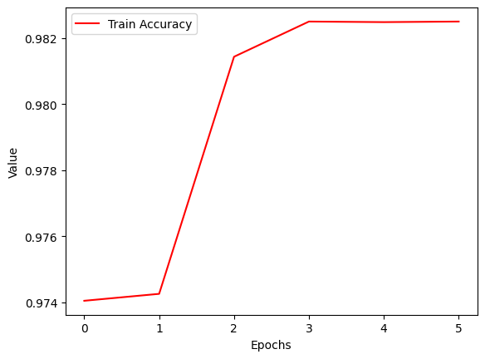

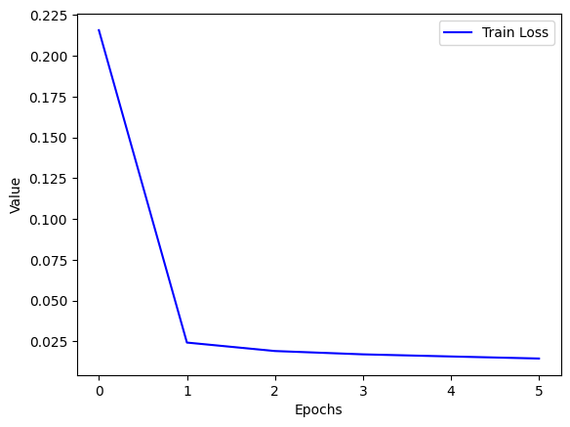

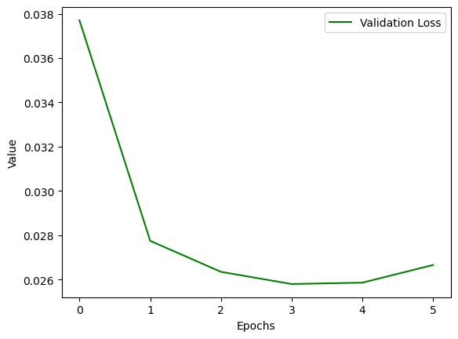

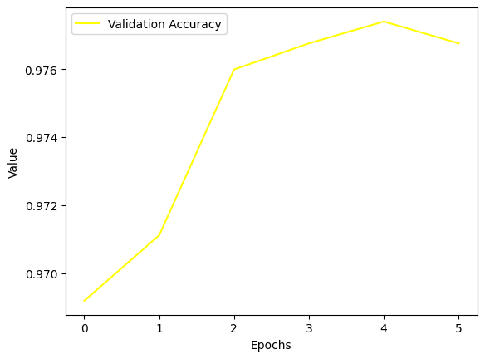

Loading model...

**Training Accuracy: 0.9825021413463387**

**Metrics of val set:**

**valData_sk_accuracy=0.9767591165896251**

valData_classification_rep =

precision recall f1-score support

<EOT> 1.00 1.00 1.00 573

<SOT> 1.00 1.00 1.00 573

adj 0.96 0.89 0.93 227

adp 0.99 0.99 0.99 1415

adv 0.81 0.81 0.81 59

aux 0.97 0.97 0.97 266

cconj 1.00 1.00 1.00 107

det 0.99 0.86 0.92 568

intj 1.00 1.00 1.00 35

noun 0.98 0.99 0.98 1143

num 0.94 0.99 0.96 131

part 0.90 0.89 0.90 73

pron 0.86 0.99 0.92 414

propn 0.99 0.99 0.99 1551

verb 0.98 0.98 0.98 653

**accuracy 0.98 7788**

**macro avg 0.96 0.96 0.96 7788**

**weighted avg 0.98 0.98 0.98 7788**

**valData_recall_micro=0.9767591165896251**

**valData_recall_macro=0.9577204100124747**

**valData_f1_micro=0.9767591165896251**

**valData_f1_macro=0.9573463444351754**

valData_confusion_mat =

[[ 573 0 0 0 0 0 0 0 0 0 0 0 0 0

0]

[ 0 573 0 0 0 0 0 0 0 0 0 0 0 0

0]

[ 0 0 203 0 7 0 0 0 0 11 3 0 0 2

1]

[ 0 0 0 1407 0 0 0 0 0 1 0 6 1 0

0]

[ 0 0 5 0 48 1 0 0 0 2 1 0 0 0

2]

[ 0 0 0 0 0 258 0 0 0 0 0 0 0 0

8]

[ 0 0 0 0 0 0 107 0 0 0 0 0 0 0

0]

[ 0 0 0 10 0 0 0 491 0 0 1 0 66 0

0]

[ 0 0 0 0 0 0 0 0 35 0 0 0 0 0

0]

[ 0 0 3 0 0 0 0 0 0 1130 1 0 0 9

0]

[ 0 0 0 1 0 0 0 0 0 0 130 0 0 0

0]

[ 0 0 0 8 0 0 0 0 0 0 0 65 0 0

0]

[ 0 0 0 0 0 0 0 4 0 1 0 1 408 0

0]

[ 0 0 0 0 1 0 0 0 0 7 2 0 0 1539

2]

[ 0 0 0 0 3 6 0 0 0 2 1 0 0 1

640]]

**Metrics of test set:**

**testData_sk_accuracy=0.9770381836945304**

testData_classification_rep =

precision recall f1-score support

<EOT> 1.00 1.00 1.00 586

<SOT> 1.00 1.00 1.00 586

adj 0.91 0.95 0.93 220

adp 1.00 1.00 1.00 1434

adv 0.82 0.67 0.74 76

aux 0.95 1.00 0.97 256

cconj 1.00 1.00 1.00 109

det 0.99 0.87 0.92 512

intj 1.00 1.00 1.00 36

noun 0.99 0.99 0.99 1166

num 0.88 0.96 0.92 127

part 0.98 0.96 0.97 56

pron 0.85 0.98 0.91 392

propn 0.99 0.99 0.99 1567

verb 0.99 0.96 0.97 629

**accuracy 0.98 7752**

**macro avg 0.96 0.96 0.95 7752**

**weighted avg 0.98 0.98 0.98 7752**

**testData_recall_micro=0.9770381836945304**

**testData_recall_macro=0.9553220963694653**

**testData_f1_micro=0.9770381836945304**

**testData_f1_macro=0.954684369349297**

testData_confusion_mat =

[[ 586 0 0 0 0 0 0 0 0 0 0 0 0 0

0]

[ 0 586 0 0 0 0 0 0 0 0 0 0 0 0

0]

[ 0 0 210 0 3 0 0 0 0 1 0 0 0 4

2]

[ 0 0 1 1429 0 0 0 0 0 1 0 1 2 0

0]

[ 0 0 15 2 51 1 0 0 0 1 2 0 0 3

1]

[ 0 0 0 0 0 255 0 0 0 0 0 0 0 0

1]

[ 0 0 0 0 0 0 109 0 0 0 0 0 0 0

0]

[ 0 0 0 1 1 0 0 443 0 1 0 0 65 1

0]

[ 0 0 0 0 0 0 0 0 36 0 0 0 0 0

0]

[ 0 0 1 0 1 0 0 0 0 1155 3 0 0 5

1]

[ 0 0 1 0 0 2 0 0 0 0 122 0 0 1

1]

[ 0 0 0 2 0 0 0 0 0 0 0 54 0 0

0]

[ 0 0 0 0 0 0 0 6 0 0 1 0 385 0

0]

[ 0 0 2 0 1 0 0 0 0 8 6 0 0 1549

1]

[ 0 0 1 1 5 10 0 0 0 4 4 0 0 0

604]]

**Model : lstm_model_2.pt**

**Parameters:**

**model = LSTM(128, 128, 1, len(trainData.vocab), len(trainData.tagVocab))**

**optimizer = torch.optim.Adam(model.parameters(), lr=0.025)**

**train_loss_list, valid_loss_list, train_accuracy_list, valid_accuracy_list = train(model, trainData, optimizer, criterion, valData, 4, "Test2")**

Training model...

Validation loss: 0.03000626340508461

Epoch 1 loss: 0.09359400103619295

Validation loss: 0.027040695771574974

Epoch 2 loss: 0.020520129703235492

Validation loss: 0.027457769960165024

Validation loss increased

Epoch 3 loss: 0.01844894391164851

Validation loss: 0.030191484838724136

Validation loss increased

Epoch 4 loss: 0.017633233306262253

Validation loss: 0.029461102560162544

Epoch 5 loss: 0.017281378668024025

Validation loss: 0.0271297600120306

Epoch 6 loss: 0.016205696170148786

Validation loss: 0.02963349223136902

Validation loss increased

Epoch 7 loss: 0.016253406140230485

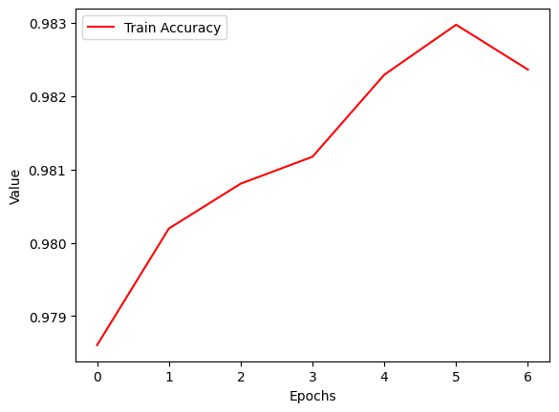

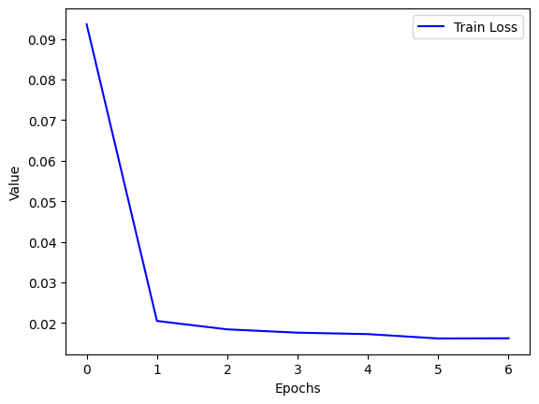

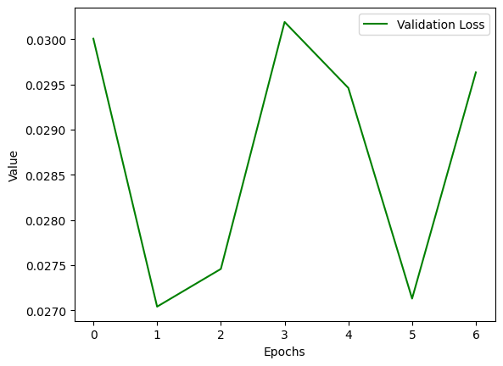

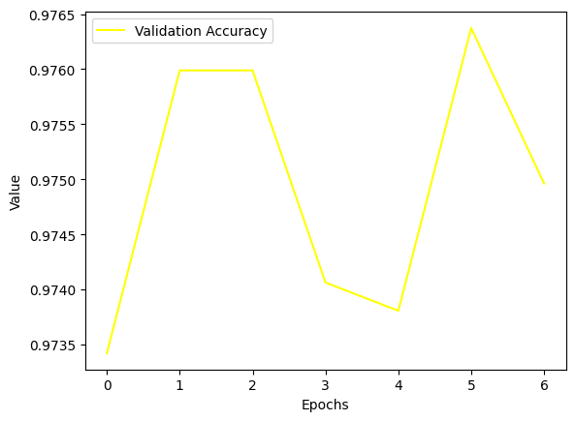

Loading model...

**Training Accuracy: 0.9823622983201357**

**Metrics of val set:**

**valData_sk_accuracy=0.9749614791987673**

valData_classification_rep =

precision recall f1-score support

<EOT> 1.00 1.00 1.00 573

<SOT> 1.00 1.00 1.00 573

adj 0.98 0.88 0.93 227

adp 0.98 1.00 0.99 1415

adv 0.82 0.85 0.83 59

aux 0.97 0.96 0.96 266

cconj 1.00 1.00 1.00 107

det 1.00 0.85 0.92 568

intj 1.00 1.00 1.00 35

noun 0.98 0.98 0.98 1143

num 0.96 0.99 0.97 131

part 0.92 0.79 0.85 73

pron 0.86 0.99 0.92 414

propn 0.99 0.99 0.99 1551

verb 0.96 0.98 0.97 653

**accuracy 0.97 7788**

**macro avg 0.96 0.95 0.96 7788**

**weighted avg 0.98 0.97 0.97 7788**

**valData_recall_micro=0.9749614791987673**

**valData_recall_macro=0.9514734869262078**

**valData_f1_micro=0.9749614791987673**

**valData_f1_macro=0.9550053318960793**

valData_confusion_mat =

[[ 573 0 0 0 0 0 0 0 0 0 0 0 0 0

0]

[ 0 573 0 0 0 0 0 0 0 0 0 0 0 0

0]

[ 0 0 199 0 10 0 0 0 0 13 1 0 0 3

1]

[ 0 0 1 1409 0 0 0 0 0 0 0 5 0 0

0]

[ 0 0 3 0 50 1 0 0 0 2 1 0 0 0

2]

[ 0 0 0 0 0 255 0 0 0 0 0 0 0 0

11]

[ 0 0 0 0 0 0 107 0 0 0 0 0 0 0

0]

[ 0 0 0 15 0 0 0 485 0 1 0 0 67 0

0]

[ 0 0 0 0 0 0 0 0 35 0 0 0 0 0

0]

[ 0 0 0 0 1 1 0 0 0 1125 2 0 0 7

7]

[ 0 0 0 0 0 0 0 0 0 0 130 0 0 1

0]

[ 0 0 0 14 0 1 0 0 0 0 0 58 0 0

0]

[ 0 0 0 1 0 0 0 1 0 0 1 0 411 0

0]

[ 0 0 0 0 0 0 0 0 0 5 0 0 0 1542

4]

[ 0 0 0 3 0 5 0 0 0 3 1 0 0 0

641]]

**Metrics of test set:**

**testData_sk_accuracy=0.9788441692466461**

testData_classification_rep =

precision recall f1-score support

<EOT> 1.00 1.00 1.00 586

<SOT> 1.00 1.00 1.00 586

adj 0.93 0.95 0.94 220

adp 0.99 1.00 1.00 1434

adv 0.87 0.70 0.77 76

aux 0.97 1.00 0.98 256

cconj 1.00 0.99 1.00 109

det 0.99 0.86 0.92 512

intj 1.00 1.00 1.00 36

noun 0.99 0.99 0.99 1166

num 0.94 0.98 0.96 127

part 0.98 0.95 0.96 56

pron 0.85 0.98 0.91 392

propn 0.99 0.99 0.99 1567

verb 0.99 0.97 0.98 629

**accuracy 0.98 7752**

**macro avg 0.97 0.96 0.96 7752**

**weighted avg 0.98 0.98 0.98 7752**

**testData_recall_micro=0.9788441692466461**

**testData_recall_macro=0.9565420087002782**

**testData_f1_micro=0.9788441692466461**

**testData_f1_macro=0.9595992246174666**

testData_confusion_mat =

[[ 586 0 0 0 0 0 0 0 0 0 0 0 0 0

0]

[ 0 586 0 0 0 0 0 0 0 0 0 0 0 0

0]

[ 0 0 208 0 4 0 0 0 0 3 1 0 0 3

1]

[ 0 0 0 1430 0 0 0 0 0 0 0 1 2 0

1]

[ 0 0 14 1 53 1 0 0 0 2 0 0 0 5

0]

[ 0 0 0 0 0 255 0 0 0 0 0 0 0 0

1]

[ 0 0 0 0 0 0 108 1 0 0 0 0 0 0

0]

[ 0 0 0 1 0 0 0 441 0 0 0 0 68 1

1]

[ 0 0 0 0 0 0 0 0 36 0 0 0 0 0

0]

[ 0 0 0 2 2 0 0 0 0 1152 1 0 0 6

3]

[ 0 0 0 0 0 1 0 0 0 0 124 0 0 1

1]

[ 0 0 0 3 0 0 0 0 0 0 0 53 0 0

0]

[ 0 0 0 2 0 0 0 5 0 0 1 0 384 0

0]

[ 0 0 1 0 0 0 0 0 0 4 2 0 0 1559

1]

[ 0 0 0 0 2 7 0 0 0 3 3 0 0 1

613]]

**Model : lstm_model_3.pt**

**Parameters:**

**model = LSTM(32, 32, 1, len(trainData.vocab), len(trainData.tagVocab))**

**optimizer = torch.optim.Adam(model.parameters(), lr=0.001)**

**train_loss_list, valid_loss_list, train_accuracy_list, valid_accuracy_list = train(model, trainData, optimizer, criterion, valData, 4, "Test3")**

Training model...

Validation loss: 0.8267819881439209

Epoch 1 loss: 1.1788430547536308

Validation loss: 0.4886995553970337

Epoch 2 loss: 0.5591191226866707

Validation loss: 0.295136034488678

Epoch 3 loss: 0.33042034795924796

Validation loss: 0.18995629251003265

Epoch 4 loss: 0.20208776341890222

Validation loss: 0.13233111798763275

Epoch 5 loss: 0.1347428599733915

Validation loss: 0.09854885190725327

Epoch 6 loss: 0.09672956324335355

Validation loss: 0.0768512487411499

Epoch 7 loss: 0.07314069457908175

Validation loss: 0.06284667551517487

Epoch 8 loss: 0.057820455560377286

Validation loss: 0.05355506390333176

Epoch 9 loss: 0.047502332408703975

Validation loss: 0.0473376139998436

Epoch 10 loss: 0.04061129728137557

Validation loss: 0.042440060526132584

Epoch 11 loss: 0.03583047377751834

Validation loss: 0.0392436683177948

Epoch 12 loss: 0.032324917211350224

Validation loss: 0.03660435602068901

Epoch 13 loss: 0.029683746890957232

Validation loss: 0.03498818352818489

Epoch 14 loss: 0.027686630625889372

Validation loss: 0.033405497670173645

Epoch 15 loss: 0.02606684780582341

Validation loss: 0.031818464398384094

Epoch 16 loss: 0.02479759951942225

Validation loss: 0.03159680590033531

Epoch 17 loss: 0.023608263442987828

Validation loss: 0.030357791110873222

Epoch 18 loss: 0.022679021283150164

Validation loss: 0.029563358053565025

Epoch 19 loss: 0.021862877296534047

Validation loss: 0.028543829917907715

Epoch 20 loss: 0.021176391802450168

Validation loss: 0.02871806174516678

Validation loss increased

Epoch 21 loss: 0.020534275016233103

Validation loss: 0.02789631485939026

Epoch 22 loss: 0.01991789512781065

Validation loss: 0.027775801718235016

Epoch 23 loss: 0.01943285186747228

Validation loss: 0.02702191285789013

Epoch 24 loss: 0.01901908071517055

Validation loss: 0.026976900175213814

Epoch 25 loss: 0.018581606315643484

Validation loss: 0.026539985090494156

Epoch 26 loss: 0.018295775654155817

Validation loss: 0.026751255616545677

Validation loss increased

Epoch 27 loss: 0.01782489790747971

Validation loss: 0.02613043412566185

Epoch 28 loss: 0.01753297629557661

Validation loss: 0.02650010585784912

Validation loss increased

Epoch 29 loss: 0.017196768502107086

Validation loss: 0.02629624679684639

Epoch 30 loss: 0.016911642952585845

Validation loss: 0.025424018502235413

Epoch 31 loss: 0.016631542743225373

Validation loss: 0.025847498327493668

Validation loss increased

Epoch 32 loss: 0.016386105230689715

Validation loss: 0.026316218078136444

Validation loss increased

Epoch 33 loss: 0.016109455529767187

Validation loss: 0.025360288098454475

Epoch 34 loss: 0.015895636696646464

Validation loss: 0.026251591742038727

Validation loss increased

Epoch 35 loss: 0.015636823199161175

Validation loss: 0.026158278807997704

Epoch 36 loss: 0.015469984599708844

Validation loss: 0.025815628468990326

Epoch 37 loss: 0.015253929355279056

Validation loss: 0.026259060949087143

Validation loss increased

Epoch 38 loss: 0.014901455112997054

Validation loss: 0.025864901021122932

Epoch 39 loss: 0.014717084185373205

Validation loss: 0.02665800228714943

Validation loss increased

Epoch 40 loss: 0.014591307945744092

Validation loss: 0.02648916095495224

Epoch 41 loss: 0.014425085544752986

Validation loss: 0.02635684609413147

Epoch 42 loss: 0.014228231284016771

Validation loss: 0.02668827772140503

Validation loss increased

Epoch 43 loss: 0.014047954471281437

Validation loss: 0.026729028671979904

Validation loss increased

Epoch 44 loss: 0.013908561180109408

Validation loss: 0.02691001445055008

Validation loss increased

Epoch 45 loss: 0.013688542278928321

Validation loss: 0.026850424706935883

Epoch 46 loss: 0.013564047125626855

Validation loss: 0.027451658621430397

Validation loss increased

Epoch 47 loss: 0.01344645422980634

Validation loss: 0.02739724889397621

Epoch 48 loss: 0.013257850755575989

Validation loss: 0.02720111981034279

Epoch 49 loss: 0.013149918404532902

Validation loss: 0.02758977562189102

Validation loss increased

Epoch 50 loss: 0.012963550099269

Validation loss: 0.027819911018013954

Validation loss increased

Epoch 51 loss: 0.012824700655304451

Validation loss: 0.028300490230321884

Validation loss increased

Epoch 52 loss: 0.012696115143680528

Validation loss: 0.028203044086694717

Epoch 53 loss: 0.012611193947299426

Validation loss: 0.0288703516125679

Validation loss increased

Epoch 54 loss: 0.012467601381714887

Validation loss: 0.028275655582547188

Epoch 55 loss: 0.012309835083893876

Validation loss: 0.028335047885775566

Validation loss increased

Epoch 56 loss: 0.012215626040306776

Validation loss: 0.028130531311035156

Epoch 57 loss: 0.012145123837182104

Validation loss: 0.02924933098256588

Validation loss increased

Epoch 58 loss: 0.012005117603702776

Validation loss: 0.028833895921707153

Epoch 59 loss: 0.011917717761791019

Validation loss: 0.029429219663143158

Validation loss increased

Epoch 60 loss: 0.011805665036385407

Validation loss: 0.02893529273569584

Epoch 61 loss: 0.011763814669936451

Validation loss: 0.030299536883831024

Validation loss increased

Epoch 62 loss: 0.011619369621013306

Validation loss: 0.030742354691028595

Validation loss increased

Epoch 63 loss: 0.01147879188908125

Validation loss: 0.030897025018930435

Validation loss increased

Epoch 64 loss: 0.011484069381354016

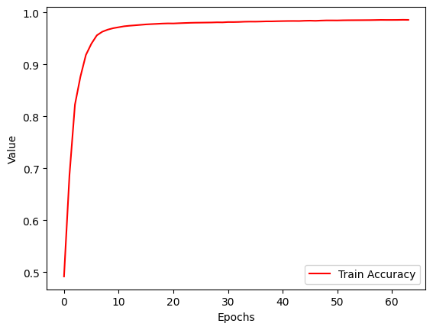

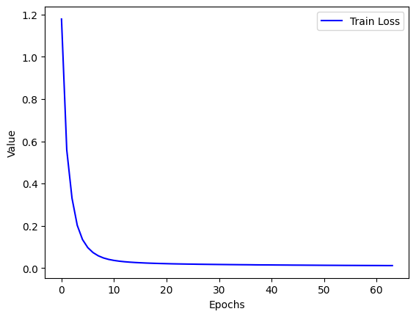

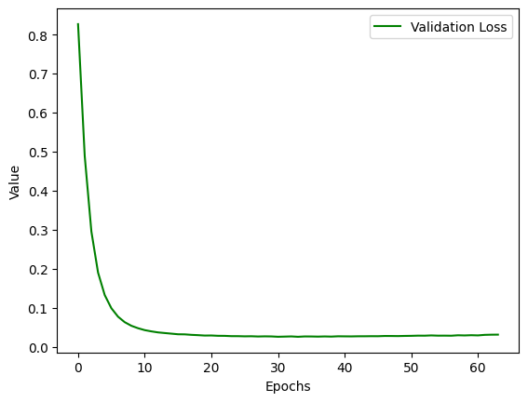

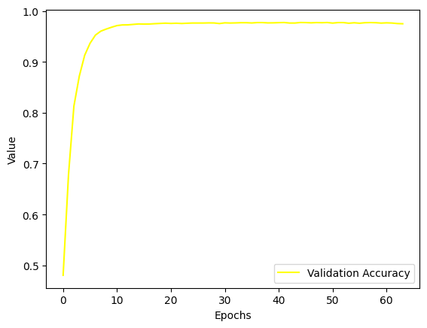

Loading model...

**Training Accuracy: 0.985910815110039**

**Metrics of val set:**

**valData_sk_accuracy=0.9748330765279918**

valData_classification_rep =

precision recall f1-score support

<EOT> 1.00 1.00 1.00 573

<SOT> 1.00 1.00 1.00 573

adj 0.98 0.89 0.93 227

adp 0.98 0.99 0.99 1415

adv 0.87 0.81 0.84 59

aux 0.99 0.94 0.96 266

cconj 1.00 1.00 1.00 107

det 0.99 0.87 0.93 568

intj 1.00 0.97 0.99 35

noun 0.98 0.99 0.98 1143

num 0.95 0.96 0.96 131

part 0.92 0.90 0.91 73

pron 0.86 0.99 0.92 414

propn 0.99 0.99 0.99 1551

verb 0.95 0.98 0.97 653

**accuracy 0.97 7788**

**macro avg 0.96 0.95 0.96 7788**

**weighted avg 0.98 0.97 0.97 7788**

**valData_recall_micro=0.9748330765279918**

**valData_recall_macro=0.9523248095715787**

**valData_f1_micro=0.9748330765279918**

**valData_f1_macro=0.9574733859194965**

valData_confusion_mat =

[[ 573 0 0 0 0 0 0 0 0 0 0 0 0 0

0]

[ 0 573 0 0 0 0 0 0 0 0 0 0 0 0

0]

[ 0 0 202 0 6 0 0 0 0 14 0 0 0 3

2]

[ 0 0 0 1404 0 0 0 1 0 0 0 6 3 0

1]

[ 0 0 4 1 48 0 0 0 0 1 1 0 1 0

3]

[ 0 0 0 0 0 249 0 0 0 0 0 0 0 0

17]

[ 0 0 0 0 0 0 107 0 0 0 0 0 0 0

0]

[ 0 0 0 13 0 0 0 494 0 0 1 0 60 0

0]

[ 0 0 0 0 0 0 0 0 34 0 0 0 0 0

1]

[ 0 0 0 0 1 0 0 0 0 1127 2 0 0 9

4]

[ 0 0 0 0 0 0 0 0 0 2 126 0 0 2

1]

[ 0 0 0 7 0 0 0 0 0 0 0 66 0 0

0]

[ 0 0 0 1 0 0 0 4 0 1 0 0 408 0

0]

[ 0 0 1 0 0 0 0 0 0 6 1 0 0 1540

3]

[ 0 0 0 3 0 3 0 0 0 3 1 0 0 2

641]]

**Metrics of test set:**

**testData_sk_accuracy=0.9780701754385965**

testData_classification_rep =

precision recall f1-score support

<EOT> 1.00 1.00 1.00 586

<SOT> 1.00 1.00 1.00 586

adj 0.92 0.95 0.93 220

adp 1.00 1.00 1.00 1434

adv 0.87 0.70 0.77 76

aux 0.99 0.97 0.98 256

cconj 1.00 1.00 1.00 109

det 0.98 0.87 0.92 512

intj 1.00 1.00 1.00 36

noun 0.99 0.99 0.99 1166

num 0.97 0.93 0.95 127

part 0.98 0.98 0.98 56

pron 0.85 0.97 0.91 392

propn 0.99 0.99 0.99 1567

verb 0.96 0.99 0.98 629

**accuracy 0.98 7752**

**macro avg 0.97 0.96 0.96 7752**

**weighted avg 0.98 0.98 0.98 7752**

**testData_recall_micro=0.9780701754385965**

**testData_recall_macro=0.9557698626049818**

**testData_f1_micro=0.9780701754385965**

**testData_f1_macro=0.9600307956029778**

testData_confusion_mat =

[[ 586 0 0 0 0 0 0 0 0 0 0 0 0 0

0]

[ 0 586 0 0 0 0 0 0 0 0 0 0 0 0

0]

[ 0 0 209 0 3 0 0 0 0 4 0 0 0 2

2]

[ 0 0 0 1430 0 0 0 0 0 0 0 1 2 0

1]

[ 0 0 15 1 53 1 0 0 0 2 0 0 0 3

1]

[ 0 0 0 0 0 249 0 0 0 0 0 0 0 0

7]

[ 0 0 0 0 0 0 109 0 0 0 0 0 0 0

0]

[ 0 0 0 2 0 0 0 445 0 0 0 0 63 1

1]

[ 0 0 0 0 0 0 0 0 36 0 0 0 0 0

0]

[ 0 0 2 0 2 0 0 0 0 1149 0 0 0 8

5]

[ 0 0 0 0 0 0 0 0 0 2 118 0 0 3

4]

[ 0 0 0 1 0 0 0 0 0 0 0 55 0 0

0]

[ 0 0 0 2 0 0 0 7 0 0 1 0 382 0

0]

[ 0 0 1 0 1 0 0 0 0 7 2 0 0 1554

2]

[ 0 0 1 1 2 1 0 0 0 2 1 0 0 0

621]]